**DSA (Lab) Task 11 (1, 2)**

**Name: Waseem Arshad**

**RollNo: 052**

**Dept: software engineering**

**Explanation (1)**

Implements a Queue using an Array in C++.

Uses two variables: front and rear to track the start and end of the queue.

Supports three main operations:

* Enqueue: Adds an element at the rear.
* Dequeue: Removes an element from the front.
* Display: Shows all elements from front to rear**.**

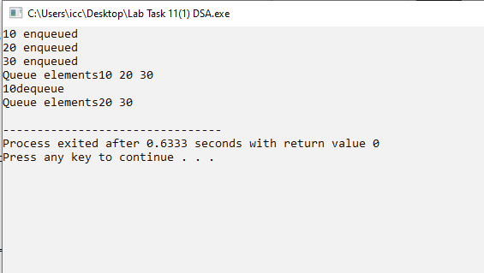

**Explanation (2)**

